**WISDOM CITY VOCATIONAL SECONDARY SCHOOL**

**UGANDA CERTIFICATE FOR LOWER SECONDARY EDUCATION**

**END OF TERM 1 EXAMINATION 2023**

**S.3 CHEMISTRY PAPER 1**

**2 HOURS 30 MINUTES**

**CANDIDATE’S NAME: …………………………………………………………………………………………………………….**

**CANDIDATE’S NUMBER: …………………………………………………………………………………………………………**

**INSTRUCTIONS**

i) This paper consists of two sections, A and B. Section A consists of 10 structural question, Section B has Essay or Semi structured.

ii) Answer all questions in section A in the space provided and attempt only two questions in section B.

iii) Answer each question on a fresh answer sheet provided.

iv) Use a blue or black ink pen only and pencil for illustrations.

**SECTION A**

**Answer all questions in this section in the spaces provided.**

1. State how the following chemical processes have contributed to our country.

a) Manufacture of cement (1 mark)

…………………………………………………………………………………………………………………………………………………………………………………………………………………………………………………………………………………………….

b) Manufacture of Sugar (1 mark)

……………………………………………………………………………………………………………………………………………………………………………………………………………………………………………………………………………………………..

c) Sewage treatment (1 mark)

………………………………………………………………………………………………………………………………………………………………………………………………………………………………………………………………………………………………

d) Manufacture of fertilizers (1 mark)

……………………………………………………………………………………………………………………………………………………………………………………………………………………………………………………………………………………………

1. Explain the following observations by using the idea of moving particles.

a) Wet clothes hanging on a line become dry even in cold weather

…………………………………………………………………………………………………………………………………………………………………………………………………………………………………………………………………………………………………………………………………………………………………………………………………………………………………………..

b) If you put some sugar in tea, the tea will become sweet even when you don’t stir.

…………………………………………………………………………………………………………………………………………………………………………………………………………………………………………………………………………………………………………………………………………………………………………………………………………………………………………….

c) If you place a balloon over the top of a test tube that contains water then you heat the water, the balloon blows up.

…………………………………………………………………………………………………………………………………………………………………………………………………………………………………………………………………………………………………………………………………………………………………………………………………………………………………………………………………………………………………………………………………..

1. A group of S.1 students at Naalya S.S carried out an investigation to find out what happens to materials when hammered and heated. Study the table below fill answers to the questions. (4 marks)

|  |  |  |
| --- | --- | --- |
| Material | Observation when hit with a hammer | Observation when heated |
| a. Wood |  |  |
| b. Glass |  |  |
| c. Concrete |  |  |
| d. Metal |  |  |

1. Argon, oxygen and nitrogen are obtained from air by fractional distillation of liquid air at -2500C where liquid air is warmed up and the gases are collected one by one.

a) State whether liquid air is a mixture or a pure substance? (1/2 marks)

……………………………………………………………………………………………………………………………………………………………………………………………………………………………………………………………………………………………..

b) Explain why fractional distillation is used instead of simple distillation. (1 $\frac{1}{2} marks$)

………………………………………………………………………………………………………………………………………………………………………………………………………………………………………………………………………………………………………………………………………………………………………………………………………………………………………………

c) During the distillation, nitrogen gas is obtained first then argon and oxygen. Explain this phenomenon. (1 mark)

…………………………………………………………………………………………………………………………………………………………………………………………………………………………………………………………………………………………………………………………………………………………………………………………..

d) Name the gases which are not collected through the fractionating column during the above process. (1 mark)

……………………………………………………………………………………………………………………………………………………………………………………………………………………………………………………………………………………………………………………………………………………………………………………………………………………………………………….

1. i) Define the term air pollution (1 mark)

……………………………………………………………………………………………………………………………………………………………………………………………………………………………………………………………………………………………..

ii) Name any 4 sources of air pollution you know. (2 marks)

………………………………………………………………………………………………………………..

………………………………………………………………………………………………………………….

…………………………………………………………………………………………………………………

…………………………………………………………………………………………………………………………….

iii) State any two gases that are produced by car engines that act as pollutants (1 mark)

…………………………………………………………………………………………………………………………………………………………………………………………………………………………………………………………………………………………..

1. The cook left knife outside the compound for a winter night, it was found that the knife turned dark brown on the surface the following day.

a) What is the chemical name for the dark brown coating? (1 mark)

……………………………………………………………………………………..

b) What conditions led to the formation of the dark brown coating? (1 mark)

…………………………………………………………………………………………………

………………………………………………………………………………………………………

c) State any two advantages of the above process to the economy (2 marks)

…………………………………………………………………………………………………………………………………………………………………………………………………………………………………………………………………………………………….

1. i) State the difference between a radical and an element (2 marks)

………………………………………………………………………………………………………………………………………………………………………………………………………………………………………………………………………………………………………………………………………………………………………………………………………………………………………………………………………………………………………………………………………………………………………………………………

ii) Name any two examples of radicals you know. (2 marks)

………………………………………………………………………………………………………………………………………………………………………………………………………………………………………………………………………………………………

1. a) What do you understand by the term ‘’rocks’’? (1 mark)

……………………………………………………………………………………………………………………………………………………………………………………………………………………………………………………………………………………………

b) Mention any three importances of rocks to the economic development of a country like Uganda. (3 marks)

………………………………………………………………………………………………………………………………………………………………………………………………………………………………………………………………………………………………………………………………………………………………………………………………………………………………………………

1. Classify the following statements as TRUE or FALSE.

a) Digesting sugar with the amylase in saliva is a chemical change (1 mark)

b) Electro planting a metal is a physical change. (1 mark)

c) All physical changes are reversible (1 mark)

d) All the chemical changes are irreversible. (1 mark)

1. i) Describe what an acid is?

…………………………………………………………………………………………………………………………………………………………………………………………………………………………………………………………………………………….

ii) Name the acid found in the following substances

i) Tea ……………………………………………… iii) Urine ………………………………

ii) Lemon Juice ………………………………… iv) Digestive juice in stomach……………………..

**SECTION B**

**Answer only two questions in this section and any additional question will not be marked**

1. a) Explain the difference between an acid and an alkali (2 marks)

b) State any 4 sources of acid that you know. (2 marks)

c) i) With the aid of equations, describe an experiment that you would carryout to prepare a salt of sodium Chloride using sodium oxide. (07 marks)

ii) Describe the uses of bases in everyday life (4 marks)

1. a) Name 5 sources of natural water (2 $\frac{1}{2 }$ marks)

(b) With the aid of a diagram describe the modelling of the water cycle and how the processes involved are interconnected. (8 marks)

c) i) Describe a simple process of making water safe for drinking at home (3 marks)

ii) State any three properties of polluted water. (1 $\frac{1}{2}$ marks)

1. Write a sentence explaining each of these observations if you don’t know the answer use your scientific knowledge to suggest one.

a) Rain water is slightly acidic (2 marks)

b) If you cover a fire with sand, it stops burning (2 marks)

c) The leaves of water plant are often covered with bubbles of air when the sunshine on them. If the bubbles are collected they will relight a glowing splint (2 marks)

d) Fire burns more strongly when a wind is blowing. (2 marks)

e) The equipment in the figure (a) below, a week later the water levels were as shown in figure (b).

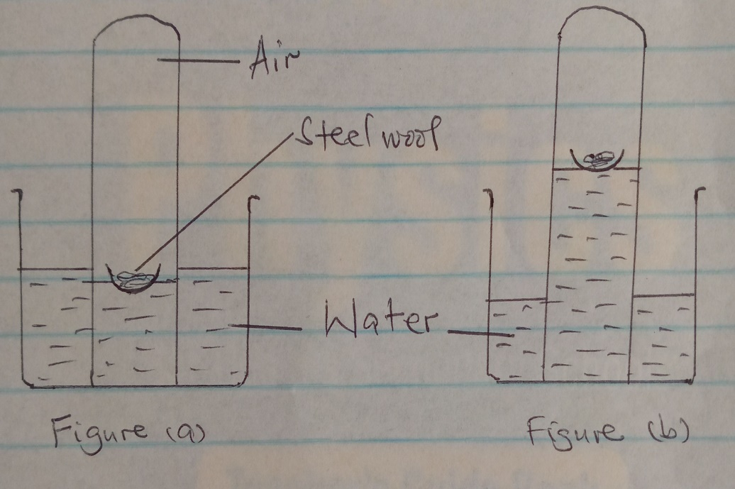

**AIM AT THE SKY; YOU WILL FALL AMONG THE STARS.**

**SUCCESS**